EDIBLES

What are they? Edibles are food products infused with THC, the psychoactive ingredient in Cannabis.
Almost any food product can be infused with Cannabis; however it is evident that some of the more popular products amongst young people throughout the UK including the South West are Cannabis sweets & gummies.
Products are often designed to look like well-known brands or types of sweets that are already available in most UK shops such as: Nerds, Gummy Bears and Fizzy Laces with often only slight or subtle changes to the packaging design.
Eating Cannabis poses risks:
- It is not possible to know how potent Cannabis edibles are by looking at them. The effects of consuming edibles are unpredictable and it can be very easy to accidentally take a larger dose than the person wanted to.

Sometimes other harmful drugs are added too.
- Due to the way it is processed by the body it takes longer to start to feel the effect. A person can begin to feel an effect from 30 mins to 2 hours, with the peak being felt at approximately 4 hours. This could result in someone using more, and becoming unwell and/or having a bad and frightening experience.
- Cannabis is illegal in any form. People may be fooled into believing Cannabis is “safe” or legal because it is in sweet or gummy form.

The images show some examples of the sweets that have been found to be in circulation in the UK:
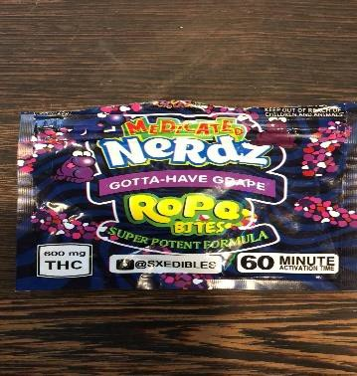

The sweets will usually have a Cannabis odour to them, even though this may be more subtle than the smell of herbal Cannabis or Cannabis resin. Most of the sweets will appear to be sugar coated and will have some sort of granular substance on the outside or within.

Signs and symptoms that someone may have used edibles:
- Paranoia
- Bloodshot Eyes
- Increased Appetite
- Lack of Motivation
- Hallucinations
- Impaired Motor Ability
- Panic Attacks
- In extreme cases Psychotic episodes

THE ONLY WAY TO PREVENT ALL OF THE RISKS OF USING EDIBLES IS NOT TO CONSUME THEM AT ALL

What to do in an emergency: Stay Calm and be reassuring, try to find out what they have taken.
If they are anxious, tense or panicky you should: sit them in a quiet and calm room, keep them away from crowds, bright lights and loud noises, tell them to take slow deep breaths, stay with them.
Don’t be afraid to call an ambulance if someone is feeling ill or having a bad experience.

