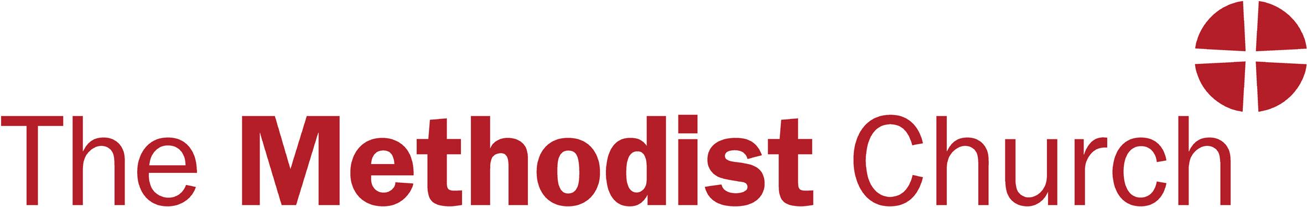

DISCLOSURE AND BARRING CHECKS
REQUEST FOR EXEMPTION
Checks are required for all ministers and local preachers,
provided that they are capable of a preaching or pastoral ministry (i.e. a public ministry).
MINISTERS  I hereby request permission to be exempt from obtaining a DBS for the following reason.  - I no longer exercise a public ministry and confirm that I will undertake no further public roles  *Signed:  Name:  Date:  Approved by Chair of District:  Signed:  Name:  Circuit and District:  Date:  District Chairs should notify the Secretary of the Conference on an annual basis in October of those ministers who have made a declaration that they no longer wish to exercise such a public ministry and so may be exempt from DBS checks. The final decision about whether the checks are required will rest with the Secretary of the Conference. | LOCAL PREACHERS  I hereby request permission to be exempt from obtaining a DBS for the following reason.  - I no longer exercise an active preaching role within the Church and confirm that I will undertake no further public roles  *Signed:  Name:  Date:  Approved by the Superintendent Minister:  Signed:  Name:  Circuit and District:  Date:  Superintendent Ministers should notify the District Chairs of those local preachers who have made a declaration that they no longer exercise an active preaching role within the Methodist Church. The final decision about whether the checks are required will rest with the Superintendent Minister.

* Where the person is unfit/lacks the capacity to complete this form the following may complete it on their behalf (next of kin, someone with power of attorney, health / social care professional). If signed above on behalf of person seeking exemption please specify below details:

Proxy Name:
Proxy Relationship:

